YEAR 8 SCIENCE
CHEMICAL SCIENCES
TEST 1: ATOMS, ELEMENTS AND THE PERIODIC TABLE

NAME: CLASS: MARK: 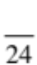

Differences between elements, compounds and mixtures can be described at a particle level.

Select the best answer for the following questions and print your answer clearly in the table provided.

1. The word ‘atom’ comes from the Greek word:

(a) atoma, meaning ‘that which cannot be seen’.
QUESTION | ANSWER
1
2
3
4
5
6
(b) atomis, meaning ‘imaginary particle’.
(c) atomos, meaning ‘that which cannot be divided’.
(d) atome, meaning ‘small sphere’.

2. An element is a substance that:

(a) is made of atoms.
(b) cannot be broken down into other substances.
(c) contains water.
(d) is a metal used in kettles.

3. The lightest element is:

(a) helium.
(b) hydrogen.
(c) lithium.
(d) carbon.

4. The component of an atom that is positively charged is the:

(a) proton.
(b) electron.
(c) neutron.
(d) electron shell.

5. Most of an atom is taken up by:

(a) the nucleus.
(b) charged particles.
(c) empty space.
(d) moving particles.

6. The mass number is:

(a) the number of protons in the nucleus.
(b) the number of protons and neutrons in the nucleus.
(c) the number of protons and electrons in the nucleus.
(d) the number of neutrons and electrons in the atom.

Short Answer Write the answer to the questions in the spaces provided.

1. Draw and label a diagram showing the various parts of an atom containing five protons and five neutrons. Label the nucleus.

Name the element this drawing represents.

(5)

2. Give the symbols for the following elements.

ELEMENT | SYMBOL
Hydrogen
Lithium
Boron
Nitrogen
Fluorine
Potassium
Sodium
Chlorine

(8)

3. Identify the contribution Democritus made to knowledge about the atom and substances.

(1)

4. When electricity is passed through water, it splits the water (H₂O) into hydrogen and oxygen. How much (volume of) hydrogen is there, compared with oxygen?

(1)

5. For each element shown below, the atomic number (top) and mass number (bottom) are shown. Use this information to identify the number of neutrons usually found in the nucleus of these atoms.
(You can do some working out to help.)

(a) zinc
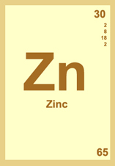

(b) gold
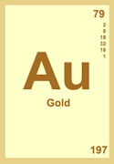

(c) scandium.
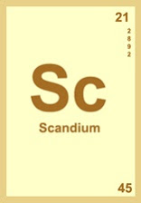
(3)

